Section A - Complete this section fully for all applications. Sheet 1 of 2

Name |  |  |  |  |  | Order Date |  |  | (SVTECH)
Address |  |  |  |  |  | Tel
 |  |  |  |  |  | Mobile
 |  |  |  |  |  | Email address:
Invoice to be sent by :
(Post or Email address if different from above)
Post Code
Contact Name |  |  |  |  | Your Reference
Purc.Order No.  (where required) |  |  |  | Vehicle Usage:  Motorhome, Living Van, Goods

Registration No. | 1st Reg. Date | Engine Type/Size + BHP (e.g. 2.3L – 130HP) |  | Base Vehicle Make (e.g Fiat)
Full 17 Digit Chassis/VIN No. |  |  | Manual or Auto | Base Vehicle Model (e.g Ducato)

Motorhome Make |  | Body Type  e.g. A-Class, Coachbuilt, Van,  other list.
Motorhome Model/Version |  | Body Type  e.g. A-Class, Coachbuilt, Van,  other list.
Details from VIN\Chassis plate –
- VERY IMPORTANT - Please supply photos of all VIN/Chassis plates fit to your vehicle.
- There may be more than one, so please supply photos of all VIN plates. Example of VIN plates
e.g.
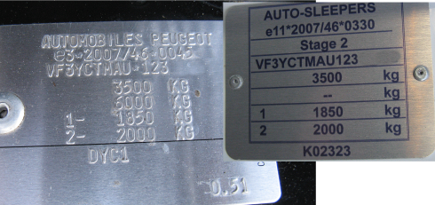
Tyre Data | TYRE SIZE  Shown on side of tyre wall  e.g. 215/70R15 | LOAD INDEX  found on tyre wall  e.g 109 / 107 R |  | Single or  Twin tyres
Axle 1
Axle 2
Axle 3
 | Towbar fitted - Yes or No
Suspension System - *** not required when downrating ***
Axle 1 |  |  | Axle 2
Suspension Type  (e.g leaf/strut/Air) |  |  | Suspension Type  (e.g leaf/strut/Air/Rubber)
Section B - Complete this section fully for all applications.
Please list the conversion type and weight required  e.g. Conversion type =Uprate  Weight required = 3850kg or Downrate – 3500kg. |  |  |  | Conversion Type |  | Weight Required **
** FOR ALL DOWNRATES, A WEIGHT TICKET IS REQUIRED IN ALL INSTANCES.- click to download declaration form
Please also list condition of vehicle when weight was recorded e.g. ½ fuel, ½ water, with/without driver/passenger etc.
Where did you hear about us?
ENQUIRY ONLY or PROCESS APPLICATION
This page does not need returning and is for use as a check list and further information

Example of VIN Plates and their location.
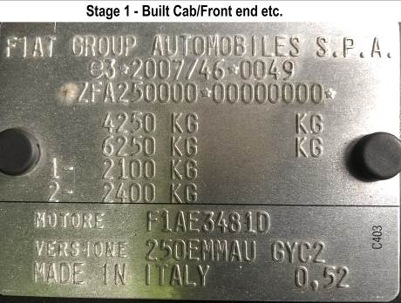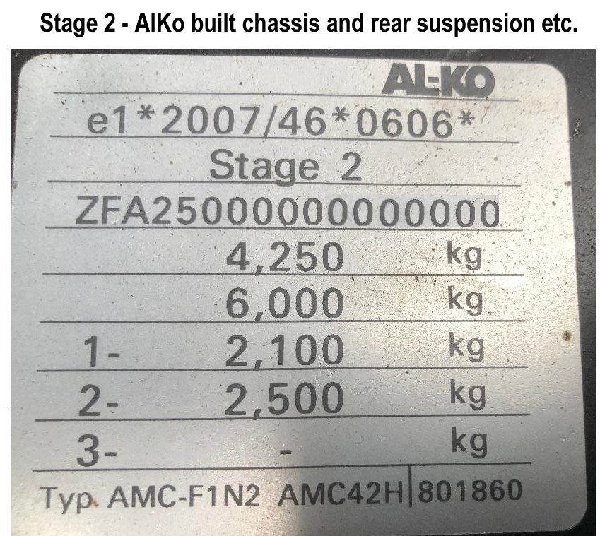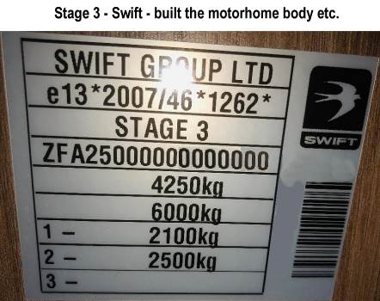
Fiat/Citroen/Peugeot plate. Found in Engine bay AlKo VIN plate next to Fiat plate in engine bay Motorhome VIN plate found around door area or behind seat.

** The motorhome Manufacturer’s plate can sometimes be hard to find and, for older vehicles or van conversions, may not have one.
Similarly if your vehicle doesn’t have AlKo suspension, you may only find the Stage 1 plate and the Motorhome manufacturer’s plate.
Please send photos of all the VIN plates you find. ** Not the one in the window

What suspension do I have?

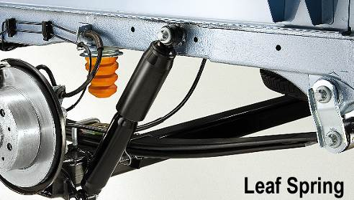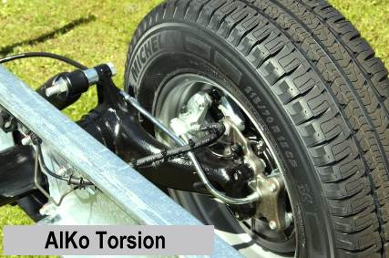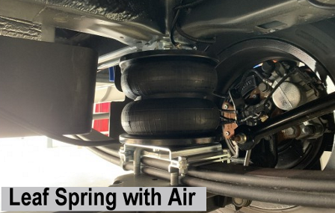

Section C – Documents to include with your application.

- Pg1 of this form, complete with full address details for the person to be invoiced.
- Photos of all VIN plates – without these your application cannot be processed.
- For a downrate, we require a weight ticket and, if over 3100kg, a declaration sheet from our website. http://www.svtech.co.uk/wp-content/uploads/2017/03/Confirmation-Sheet-for-Motorhome-downrate.pdf
- Copy of vehicle logbook – Inside page 2 required only. (not essential but helps us advise of changes).
- Where suspension changes have been made (i.e. air assist) please also include details of make and manufacturer’s model number. Please also include a photo of this as fit to the vehicle.

- For home-build conversions, that are not on the DVLA records as a motor-caravan we require:
  - Photos of inside and outside of vehicle
  - Details of any changes made to brakes, suspension or chassis.

Disclaimer
By submitting this from I declare that, to the best of my knowledge, the above information is a true description of the vehicle. I understand that failure to disclose information or the vehicle not being to this condition may cause the application to be refused.

Have you tried our weight calculator on the web? ☺ www.svtech.co.uk/lda
Like us on Facebook: SvTechLtd - Follow us on Twitter: @SvTechLtd
What we do with your information: www.svtech.co.uk/GDPR

